ROS基础 – 实训套件
实验案例 – 教学参考手册
2摄像头与机械臂相对位置的参数标定
ROS基础 – 实训套件
实验案例 – 教学参考手册
6 06 Move_base与AMCL参数设置
ROS基础 – 实训套件
实验案例 – 教学参考手册
5 创建仿真机器人与现实机器人的同步
智能控制原理与技术
实验案例
3 机械臂视觉抓取及应用
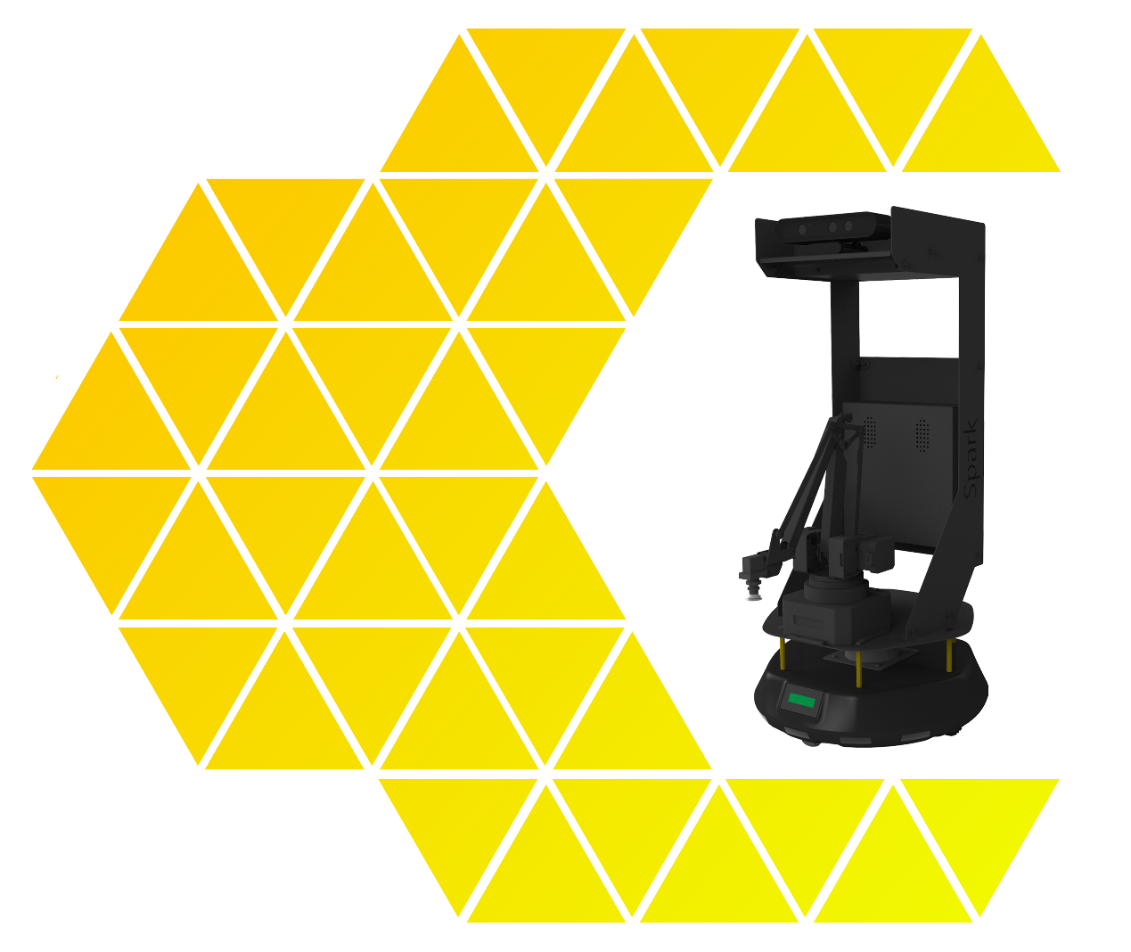


目 录
一、实验名称：机械臂视觉抓取及应用 1
1、相关技能 1
2、相关知识点 1
3、实现效果 1
4、实验要求 1
5、实现思路 2
6、验证与测试 9
7、参考答案 9

一、实验名称：机械臂视觉抓取及应用

1、相关技能
- ROS外接设备技能

2、相关知识点
- 颜色检测方法及效果
- 机械臂控制方法及效果
- 移动底盘转向及移动控制

3、实现效果
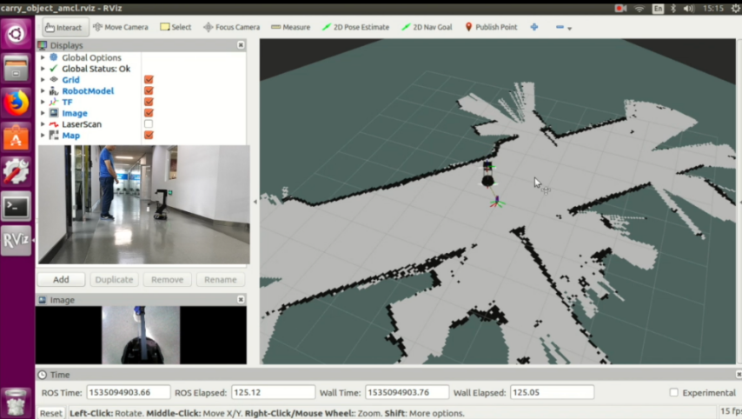
图3-1 拟合标定

4、实验要求
本实验要求：通过摄像头的图像结合机械臂运动，通过线性拟合得到相关结果。
  - SPARK硬件安装
  - 机械臂视觉抓取及应用的源码
  - 通过launch实现各个功能组合运行
  - 编译，执行

5、实现思路

  - 硬件安装
    - 在机械臂的吸盘正上方的位置贴上一个18mm X 28mm左右的长方形红色纸。把摄像头向前下方旋转90度，让其与地面平行。 如图所示：
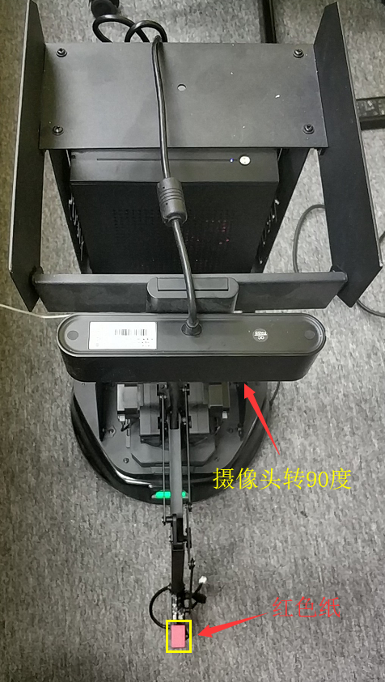

  - 机械臂视觉抓取及应用的源码
    - 查看源码，路径为：~/spark/src/spark_app/spark_carry/nodes/s_carry_object_cv3.py。
其中初始化部分源码主要是图像的订阅和机械臂位置和气泵的控制话题的发布。
+ 源码：
def onInit(self):
global xc, yc, xc_prev, yc_prev, found_count
xc = 0
yc = 0
xc_prev = xc
yc_prev = yc
found_count = 0
self.sub = rospy.Subscriber("/camera/rgb/image_raw", Image, self.image_cb, queue_size=1)
self.pub1 = rospy.Publisher('position_write_topic', position, queue_size=10)
self.pub2 = rospy.Publisher('pump_topic', status, queue_size=1)
读取已标定的拟合参数，控制气泵。
+ 源码：
def grasp(self):
print("start to grasp\n")
global xc, yc, found_count
# stop function
filename = os.environ['HOME'] + "/thefile.txt"
file_pix = open(filename, 'r')
s = file_pix.read()
file_pix.close()
arr=s.split()
a1=arr[0]
a2=arr[1]
a3=arr[2]
a4=arr[3]
a = [0]*2
b = [0]*2
a[0]=float(a1)
a[1]=float(a2)
b[0]=float(a3)
b[1]=float(a4)
print('k and b value:',a[0],a[1],b[0],b[1])
r1 = rospy.Rate(0.095)
r2 = rospy.Rate(10)
pos = position()
pos.x = a[0] * yc + a[1]
pos.y = b[0] * xc + b[1]
pos.z = 20
#控制机械臂的移动目标，并打开气泵。
self.pub1.publish(pos)
r2.sleep()
pos.z = -50
self.pub1.publish(pos)
r2.sleep()
# start pump
self.pub2.publish(1)
r2.sleep()
# go back home
pos.x = 250 #160
pos.y = 0
pos.z = 115 #55
self.pub1.publish(pos)
r1.sleep()
摄像头数据的接收和蓝色物品的检测：
+ 源码：

def image_cb(self, data):
#print("received image\n")
global xc, yc, xc_prev, yc_prev, found_count
# change to opencv
try:
cv_image1 = CvBridge().imgmsg_to_cv2(data, "bgr8")
Except CvBridgeError as e:
print('error')
# change rgb to hsv
cv_image2 = cv2.cvtColor(cv_image1, cv2.COLOR_BGR2HSV)
# extract blue
#此处为检测蓝色的物品，注意灯光对物品的影响，根据摄像头采集到的颜色的调整这个值。
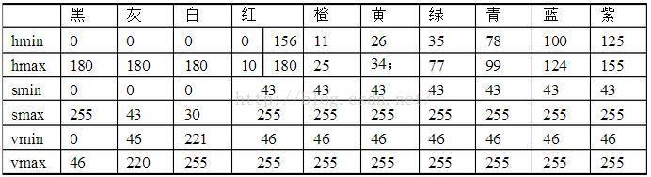
LowerBlue = np.array([100, 90, 80])
UpperBlue = np.array([130, 255, 255])
mask = cv2.inRange(cv_image2, LowerBlue, UpperBlue)
cv_image3 = cv2.bitwise_and(cv_image2, cv_image2, mask=mask)
# gray process
cv_image4 = cv_image3[:, :, 0]
# smooth and clean noise
blurred = cv2.blur(cv_image4, (9, 9))
(_, thresh) = cv2.threshold(blurred, 90, 255, cv2.THRESH_BINARY)
#此处检测物品的形状和大小25x25，根据实际的物品调整
kernel = cv2.getStructuringElement(cv2.MORPH_RECT, (25, 25))
cv_image5 = cv2.morphologyEx(thresh, cv2.MORPH_CLOSE, kernel)
cv_image5 = cv2.erode(cv_image5, None, iterations=4)
cv_image5 = cv2.dilate(cv_image5, None, iterations=4)
# detect contour
#cv2.imshow("win1", cv_image1)
#如果打开下面的显示，就可以显示出检测到颜色的灰度图，如下图所示
#cv2.imshow("win2", cv_image5)
#cv2.waitKey(1)
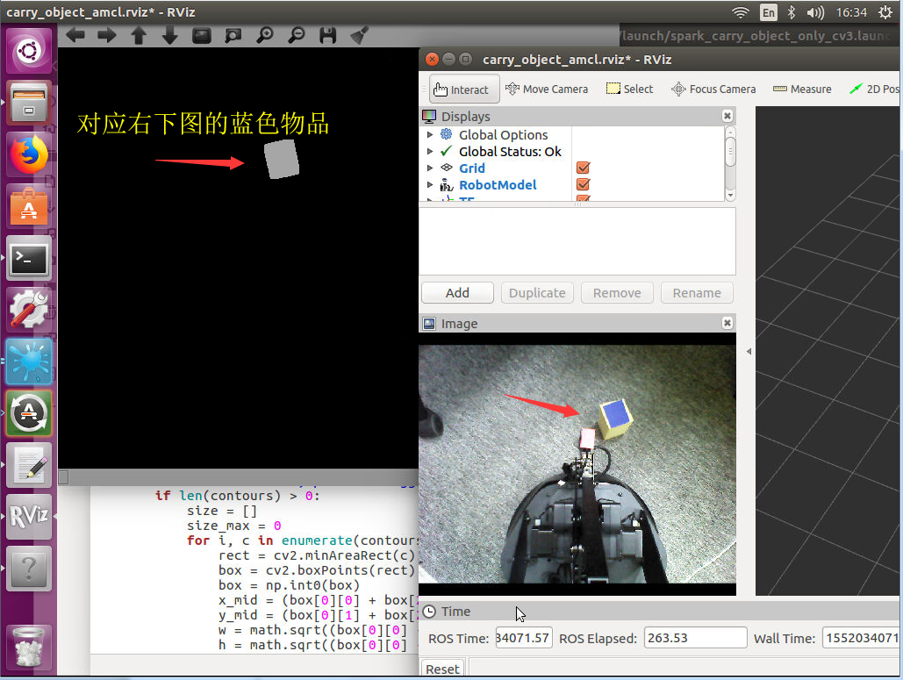
_, contours, hier = cv2.findContours(cv_image5, cv2.RETR_TREE, cv2.CHAIN_APPROX_SIMPLE)

# if find contours, pick the biggest box
if len(contours) > 0:
size = []
size_max = 0
for i, c in enumerate(contours):
rect = cv2.minAreaRect(c)
box = cv2.boxPoints(rect)
box = np.int0(box)
x_mid = (box[0][0] + box[2][0] + box[1][0] + box[3][0]) / 4
y_mid = (box[0][1] + box[2][1] + box[1][1] + box[3][1]) / 4
w = math.sqrt((box[0][0] - box[1][0]) ** 2 + (box[0][1] - box[1][1]) ** 2)
h = math.sqrt((box[0][0] - box[3][0]) ** 2 + (box[0][1] - box[3][1]) ** 2)
size.append(w * h)
if size[i] > size_max:
size_max = size[i]
index = i
xc = x_mid
yc = y_mid
# if box is not moving for 20 times
#print found_count
if found_count >= 20:
self.is_found_object = True
else:
# if box is not moving
if abs(xc - xc_prev) <= 2 and abs(yc - yc_prev) <= 2:
found_count = found_count + 1
else:
found_count = 0
else:
found_count = 0
xc_prev = xc
yc_prev = yc

建立状态机，根据状态执行相关动作。
+ 源码：
......
def build_state_machine(self):
'''
建立状态机
'''
if not self.sm_carry_object is None:
self.sm_carry_object = None
self.sm_carry_object = StateMachine(outcomes=['succeeded', 'aborted', 'preempted'])
with self.sm_carry_object:
StateMachine.add('GRASP_OBJECT', GraspObject(), transitions={'succeeded':'NAV_TO_WAYPOINT',
'aborted':'END_ABORT'})
StateMachine.add('GET_LOCATION', GetLocation(), transitions={'succeeded':'NAV_TO_WAYPOINT',
'aborted':'END_ABORT'},
remapping={'waypoint_out':'nav_waypoint'})
StateMachine.add('NAV_TO_WAYPOINT', Go2Goal(), transitions={'succeeded':'RELEASE_OBJECT',
'aborted':'END_ABORT'})
StateMachine.add('RELEASE_OBJECT', ReleaseObject(), transitions={'succeeded':'TURN_BODY_QUAR',
'aborted':'END_ABORT'})

StateMachine.add('TURN_BODY_QUAR', TurnBodyQuar(), transitions={'succeeded':'GRASP_OBJECT','aborted':'END_ABORT'})
StateMachine.add('END_ABORT', EndAbort(), transitions={'succeeded':'succeeded'})
StateMachine.add('END_SUCESS', EndSuccess(), transitions={'succeeded':'succeeded'})
......

  - 通过launch实现各个功能组合运行
    - 在SPARK实现机械臂与摄像头标定功能需要运行：
- 机械臂的驱动;
- spark驱动，包括机器人描述、相机、底盘;
- 摄像头订阅与视觉定位;
- 控制机械臂的定点移动;
- Rviz显示界面
内容如下：
+ launch文件：
<launch>
<!--spark驱动，机器人描述，相机，底盘-->
<!--include file="$(find spark_bringup)/launch/driver_bringup.launch"/-->
<include file="$(find astra_launch)/launch/astra.launch">
<arg name="rgb_processing" value="true"/>
<arg name="depth_processing" value="true"/>
<arg name="depth_registered_processing" value="false"/>
<arg name="depth_registration" value="false"/>
<arg name="disparity_processing" value="false"/>
<arg name="disparity_registered_processing" value="false"/>
</include>
<!--UARM机械臂-->
<include file="$(find swiftpro)/launch/pro_control_nomoveit.launch"/>
<!--搬运物体-->
<node pkg="spark_carry_object" type="s_carry_object_cv3.py" name="spark_carry_object_node" output="screen">
<param name ="turnbody_min_z" value = "-0.2"/>
<param name ="turnbody_max_z" value = "0.2"/>
</node>
<!--在rviz显示-->
<arg name="rvizconfig" default="$(find spark_carry_object)/rviz/carry_object_amcl.rviz" />
<node name="rviz" pkg="rviz" type="rviz" args="-d $(arg rvizconfig)" required="true"/>
<!--是否开始抓取-->
<node pkg="spark_carry_object" type="cmd_spark_carry_start.sh" name="cscs" />

</launch>

保存并命名为spark_carry_object_only_cv3.launch到~/spark/src/spark_app/spark_carry/launch/文件夹中。

  - 编译，执行
$ cd ~/spark
$ catkin_make

$ cd ~/spark
$ source ~/spark/devel/setup.bash
$ roslaunch spark_carry_object spark_carry_object_only_cv3.launch

或者直接运行一键脚本：
$ cd ~/spark
$ ./onekey.sh
# 根据提示选择第9个功能“让spark通过机械臂进行视觉抓取”

运行程序，运行效果如下：

6、验证与测试

在控制台输入
$ cd ~/spark
$ source ~/spark/devel/setup.bash
$ roslaunch spark_carry_object spark_carry_object_only_cv3.launch

或者直接运行一键脚本：
$ cd ~/spark
$ ./onekey.sh
# 根据提示选择第9个功能“让spark通过机械臂进行视觉抓取”

7、参考答案
无

